

FACULTY OF INFORMATICS & DESIGN

Diploma in Information & Communication Technology
Project 3: PRT362S
MRS S TSWANE
Group: ST2
Name and Surname :Nhlakanipho Owen Jnr Makene
Student Number : 223219665

Wireframes/Design

Register
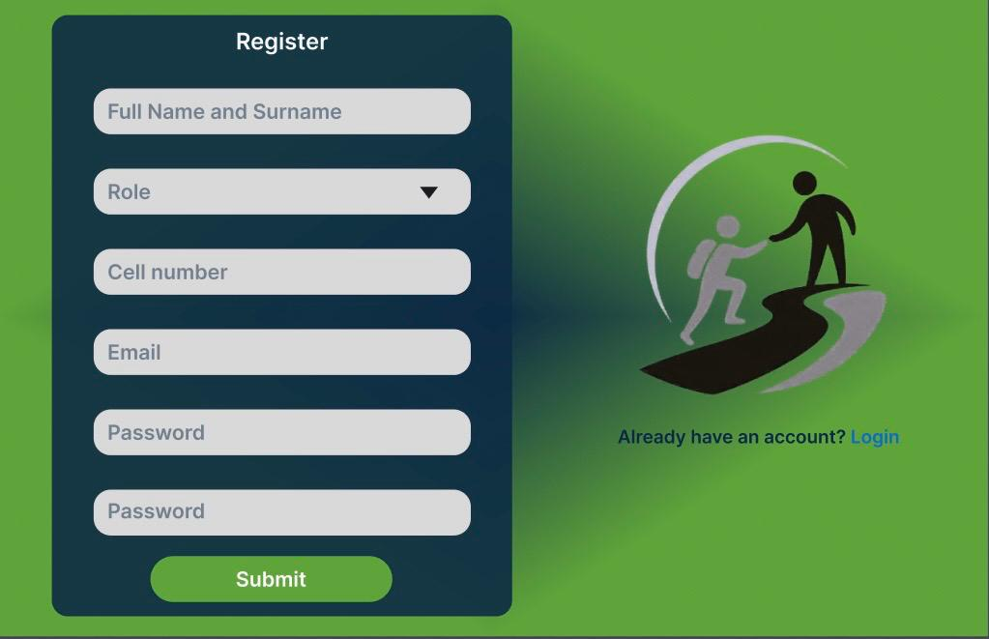
New user information is recorded in the registration form. The form probably contains the following information, based on the Student and Mentor tables in the ERD: username, first and last names, email address, password, and a user type selection (Student: HighSchool / Tertiary / Unemployed, or Mentor). A new record is created in the pertinent table upon submission.

Login
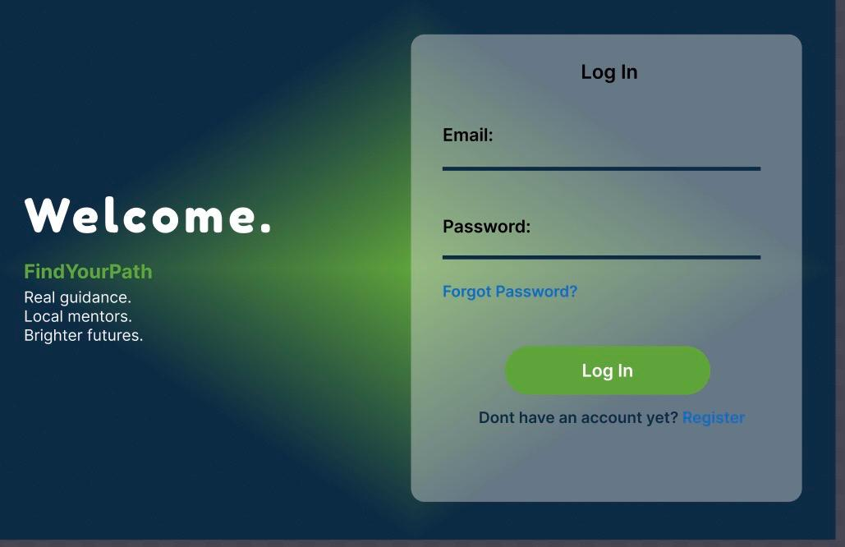
A clean, centered form with fields for username/email and password. It includes a "Login" button, a link to the Register page for new users, and a "Forgot Password" link. Both students and mentors use this same login form, with role-based redirection after authentication. The backend uses session management and password hashing as described in the scope.

Rest Password
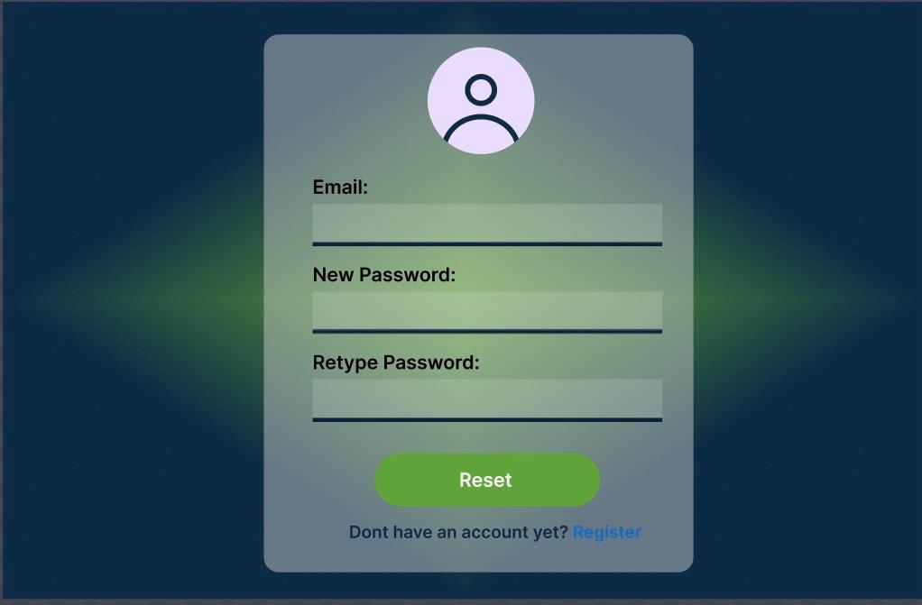
If a user forgets their password or wants to change it for security reasons, they can create a new one using the Reset Password page. Typically, the user types a new password and verifies it after entering their email address or verification code. Before safely changing the account password, the system verifies that the passwords match and satisfy security standards.

Dashboard
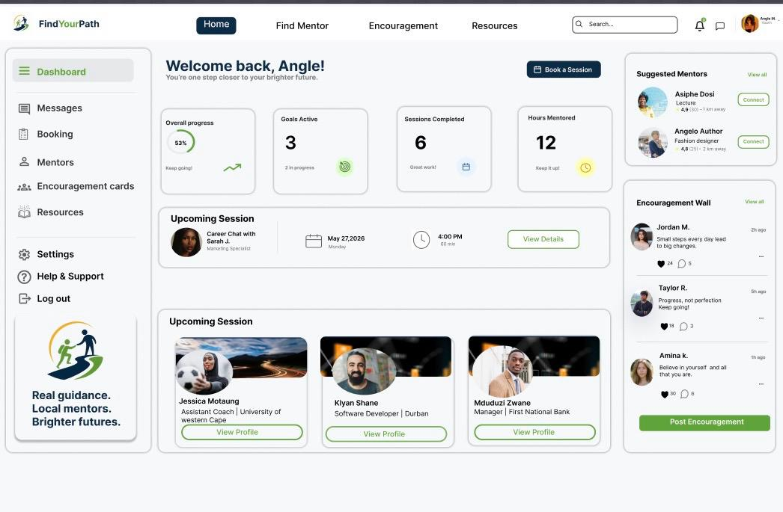

The post-login home screen personalized per user role:
- Student Dashboard: Displays suggested mentors by industry, recent communications, active mentor contacts, and scheduled reservations.
- Mentor Dashboard: Displays student messages, accepted reservations, and pending mentorship requests (MentorRequest table).
- Admin Dashboard: Probably displays system information, such as the number of users, reservations, and open RequestSupport tickets (SystemAdministrator table).

Message
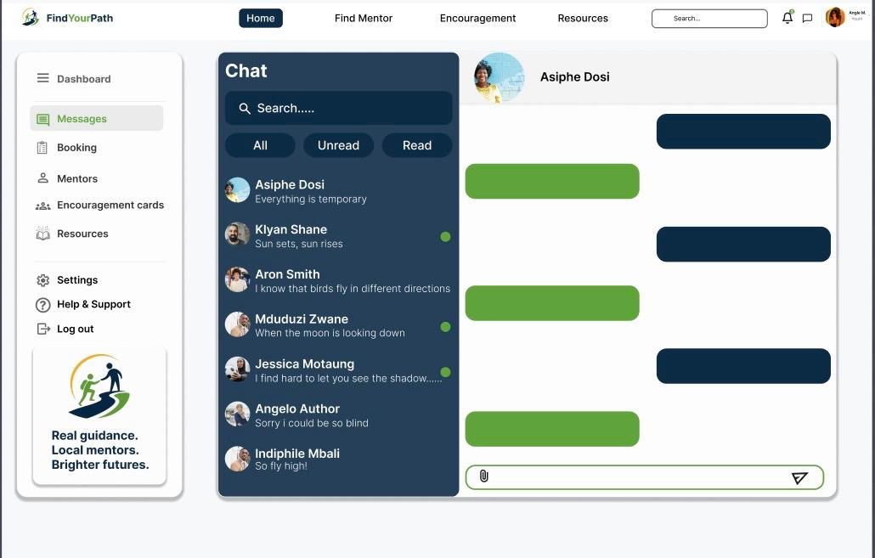
Students and mentors can communicate using a simple asynchronous messaging system (as scoped; no real-time chat). It shows the message thread on the right and a list of chats on the left. This supports the mentorship request procedure by taking the place of real-time chat while still enabling meaningful mentor-student conversation.

Booking
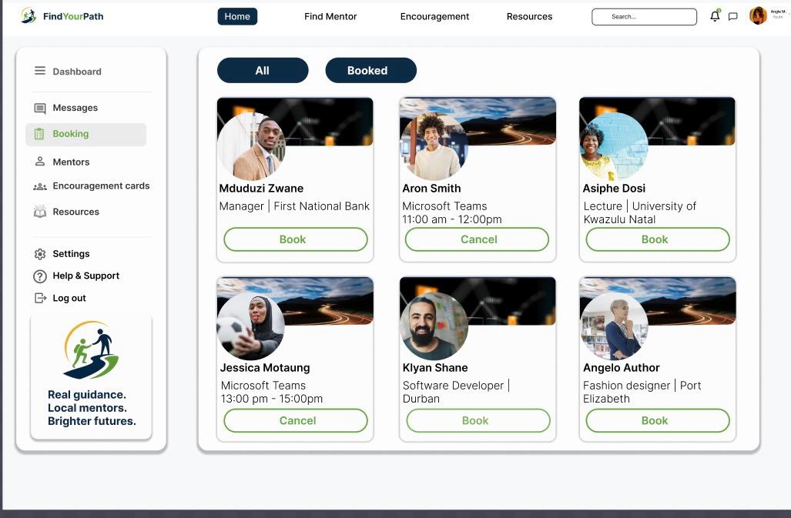
This form is used by students to arrange a mentorship session. The form records studentID, studentEmail, mentorID, mentorEmail, date, and time based on the Booking table in the ERD. The student chooses a mentor who is available, chooses a time and date, and confirms the reservation. This is a fundamental aspect of the platform.

Mentors
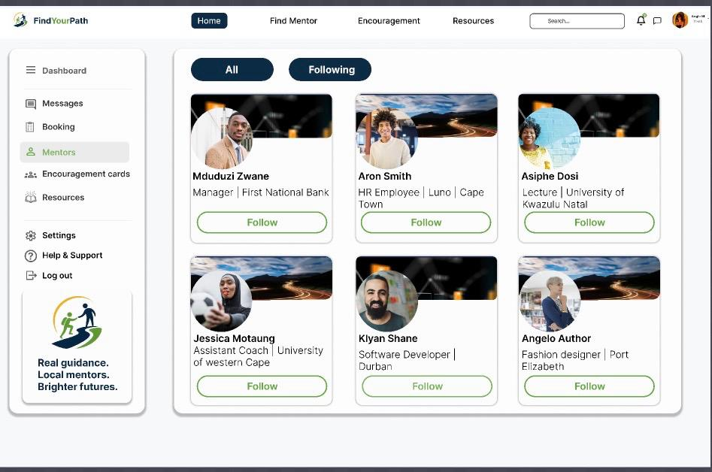

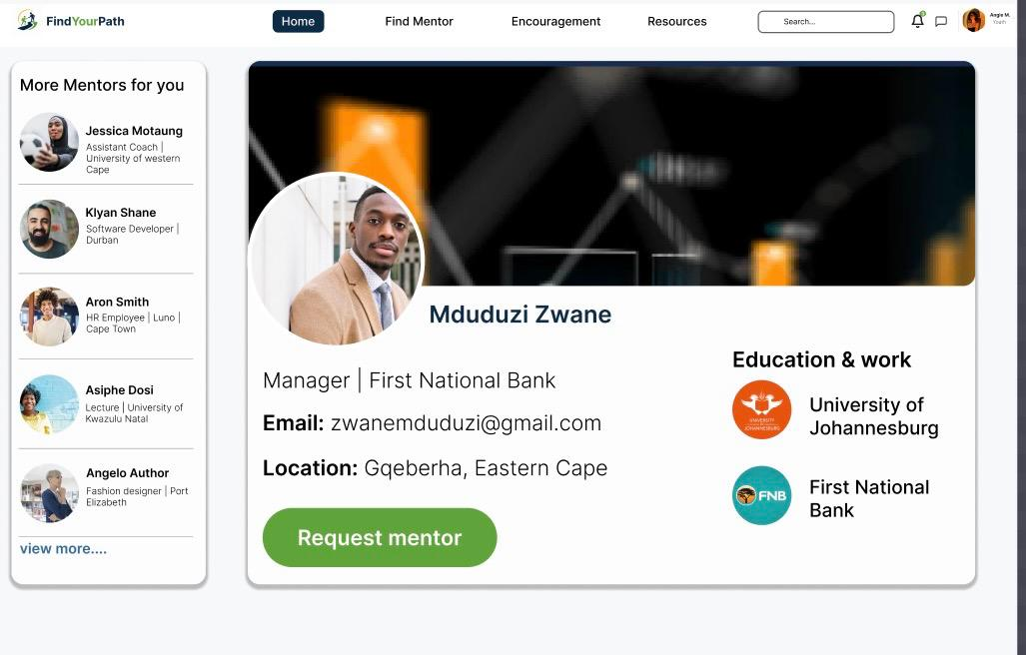
shows a mentor's complete profile, which is taken from the Mentor table and includes their name, job type, industry, email address, and maybe a bio. Before submitting a mentorship application, students can view this. Additionally, it might provide a button that links to the Booking or MentorRequest flow for scheduling a session or sending a request.

Encouragement Wall
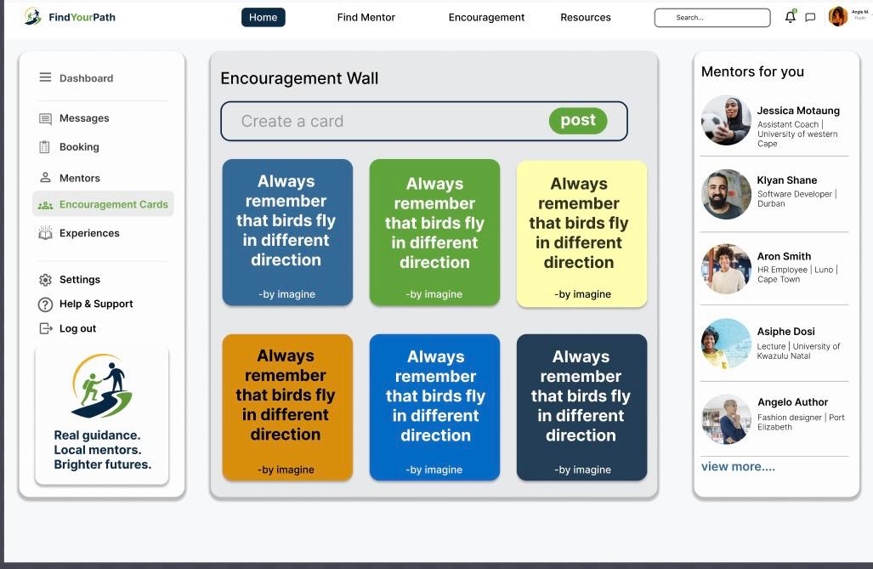
This is a community-inspired screen where users can post or view motivational messages, success stories, or career milestones. It acts as a morale-boosting social feature — students who have connected with mentors or achieved goals can share their progress. This aligns with the platform's goal of building youth confidence and motivation.

Experiences
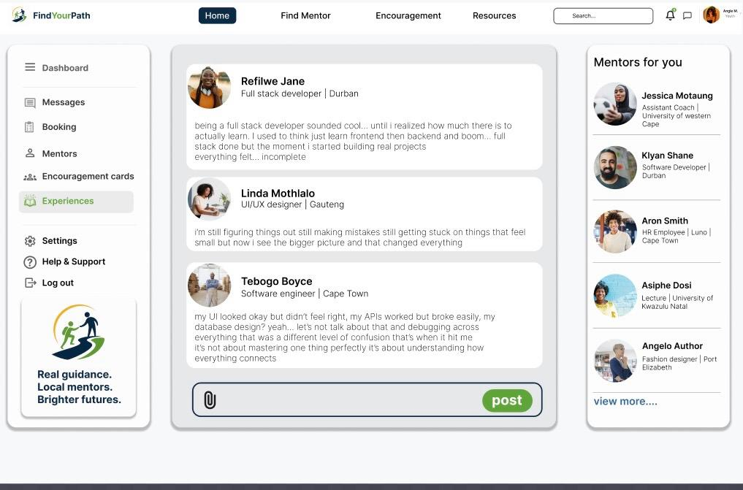
This page showcases real stories or testimonials from students who have used the platform, or career experience write-ups shared by mentors. It feeds into the MentorsContent table (which stores industry, firstName, lastName, email), giving prospective users insight into what they can gain from the platform.

Settings
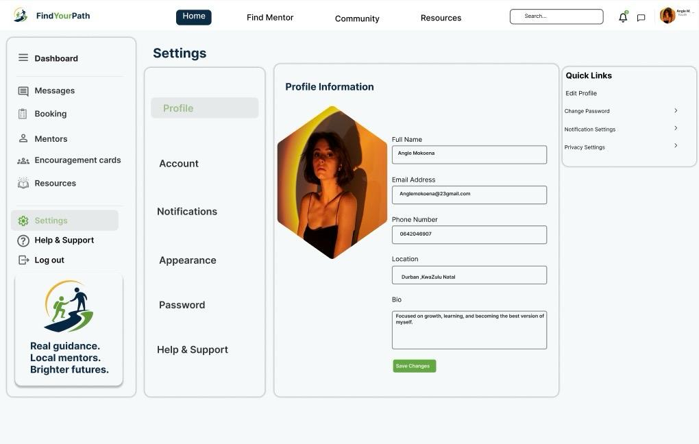
Users can edit their personal data under the Profile section of the Settings page. This contains their location, cell phone number, email address, and full name. These specifics aid in the user's identification and ensure that the system maintains accurate and current account information.

Career Explorer

Creative Arts
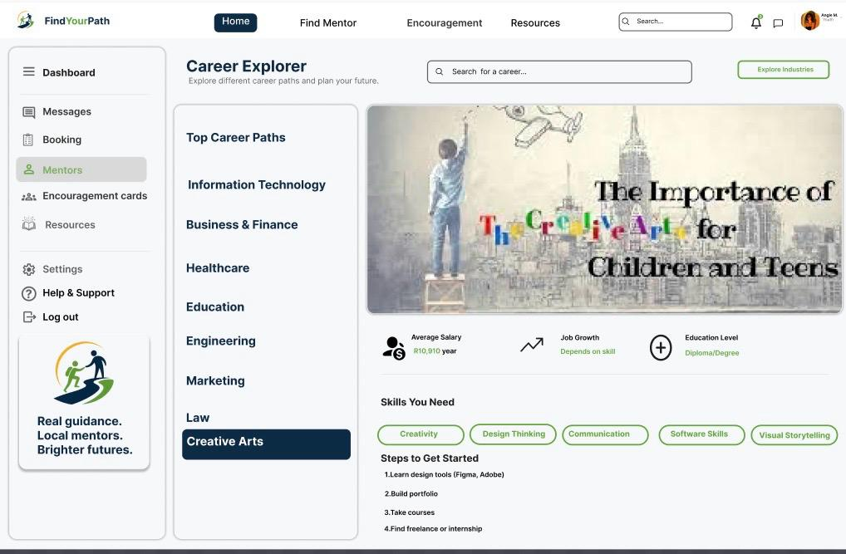
Involves design, music, writing, and visual creativity. Skills needed include creativity, imagination, artistic ability, and expression skills.

Law
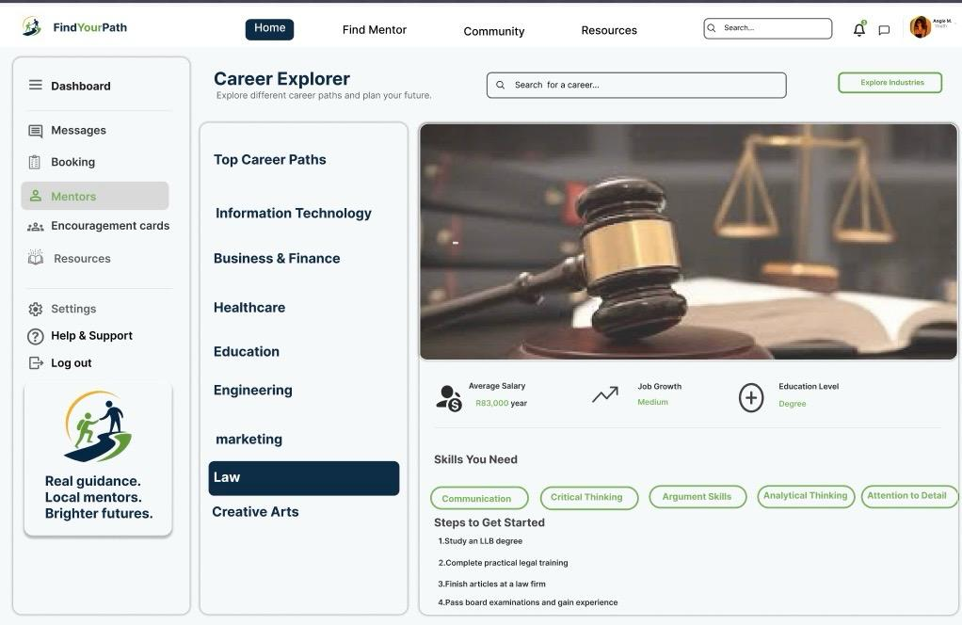
Focuses on legal systems, rules, and justice. Skills needed include critical thinking, research, communication, and attention to detail.

Marketing
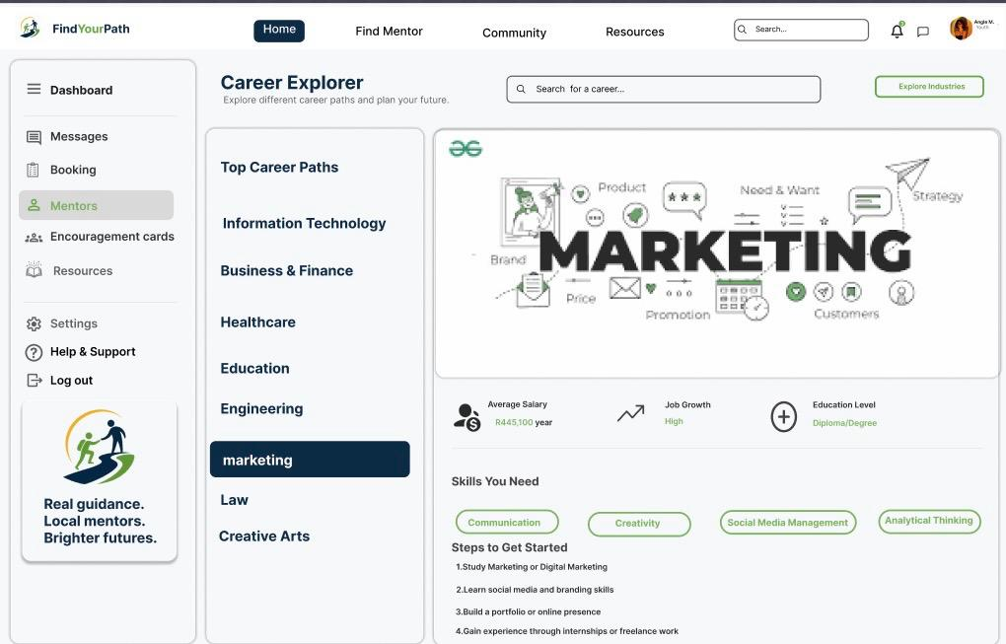
Involves promoting products and services. Skills needed include creativity, communication, digital marketing knowledge, and understanding customer behavior.

Engineering
Focuses on designing and building systems, machines, and structures. Skills needed include mathematics, problem-solving, creativity, and technical skills.

Education
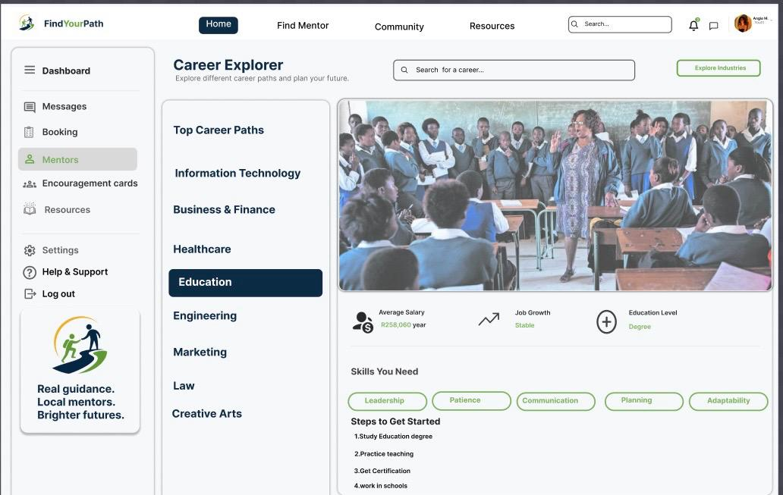
Involves teaching and guiding learners. Skills needed include communication, patience, leadership, and subject knowledge.

Healthcare
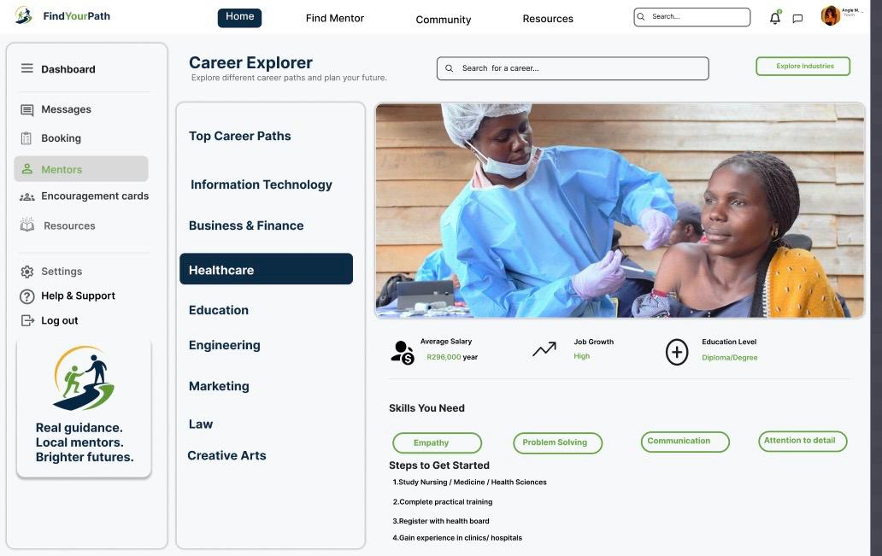
Focuses on caring for people’s health and medical needs. Skills needed include empathy, attention to detail, teamwork, and medical knowledge

Business and Finance
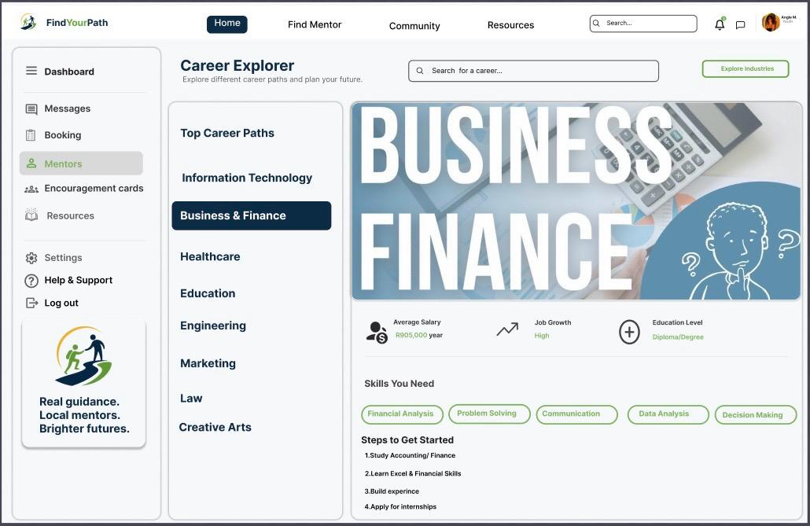
Involves managing money, companies, and financial planning. Skills needed include analytical thinking, communication, accounting knowledge, and decision-making.

Information Technology (IT)
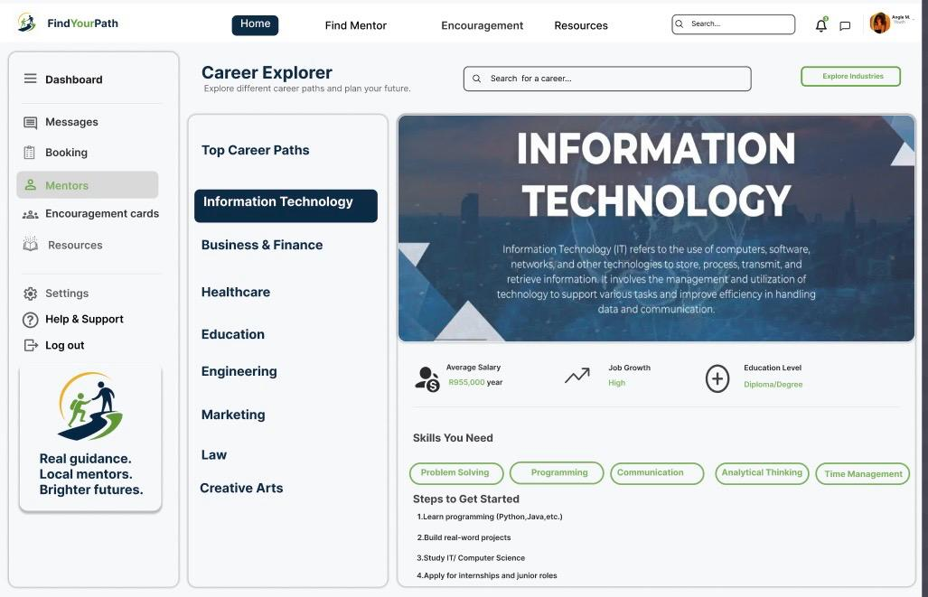
Focuses on computers, software, and systems development. Skills needed include programming, problem-solving, cybersecurity knowledge, and logical thinking.

Help & Support
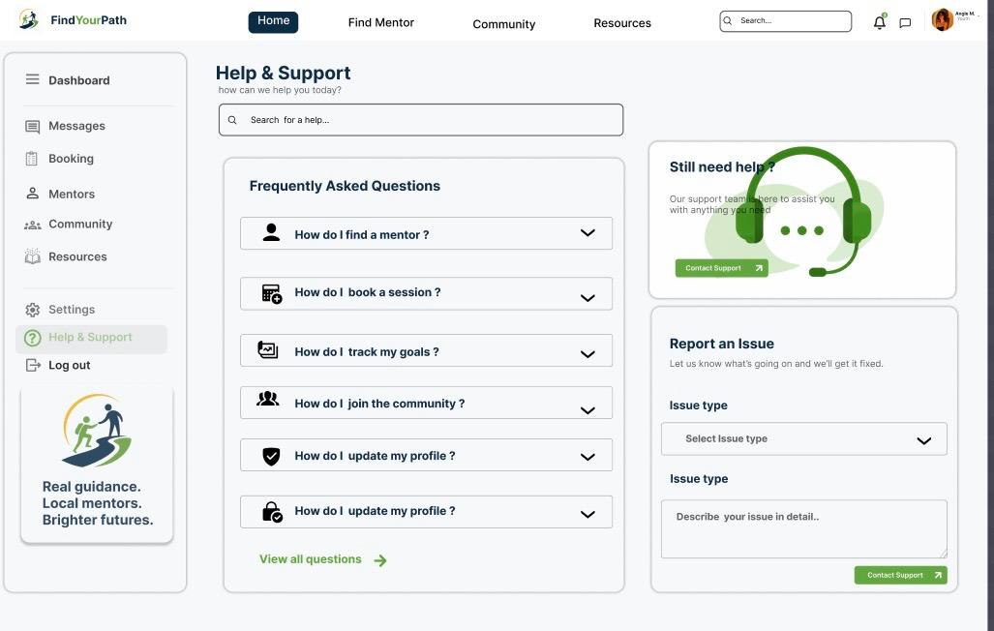 The Help & Support page provides users with guidance on how to use the system and access key features. It helps users with common tasks such as finding a mentor through the mentorship section, booking a session by selecting a mentor and choosing an available time slot, tracking goals in the goals section, joining the community through the community option, and updating their profile in the Settings page under Profile where they can edit their full name, email, cell number, and location.

Translating the wireframes into the development tools

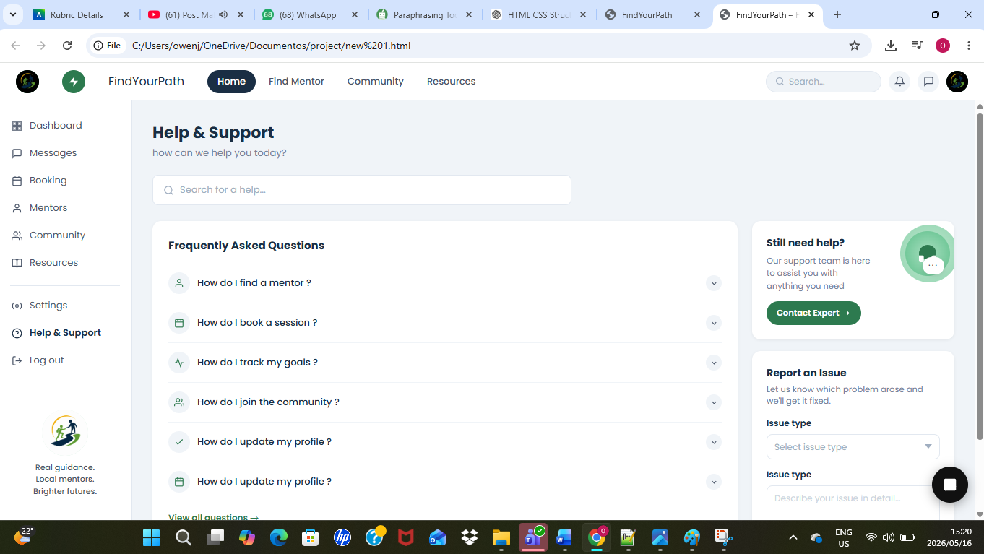
I used Notepad++ as my development environment to turn the Help & Support wireframe into a fully functional web page. JavaScript was used for interactivity, HTML was used for structure, and CSS was used for styling. To make sure the layout, design components, and user interface closely resembled the desired design, I closely adhered to the original wireframe. The end product is a functioning and responsive Help & Support page that enhances user experience by making support-related information easily accessible.

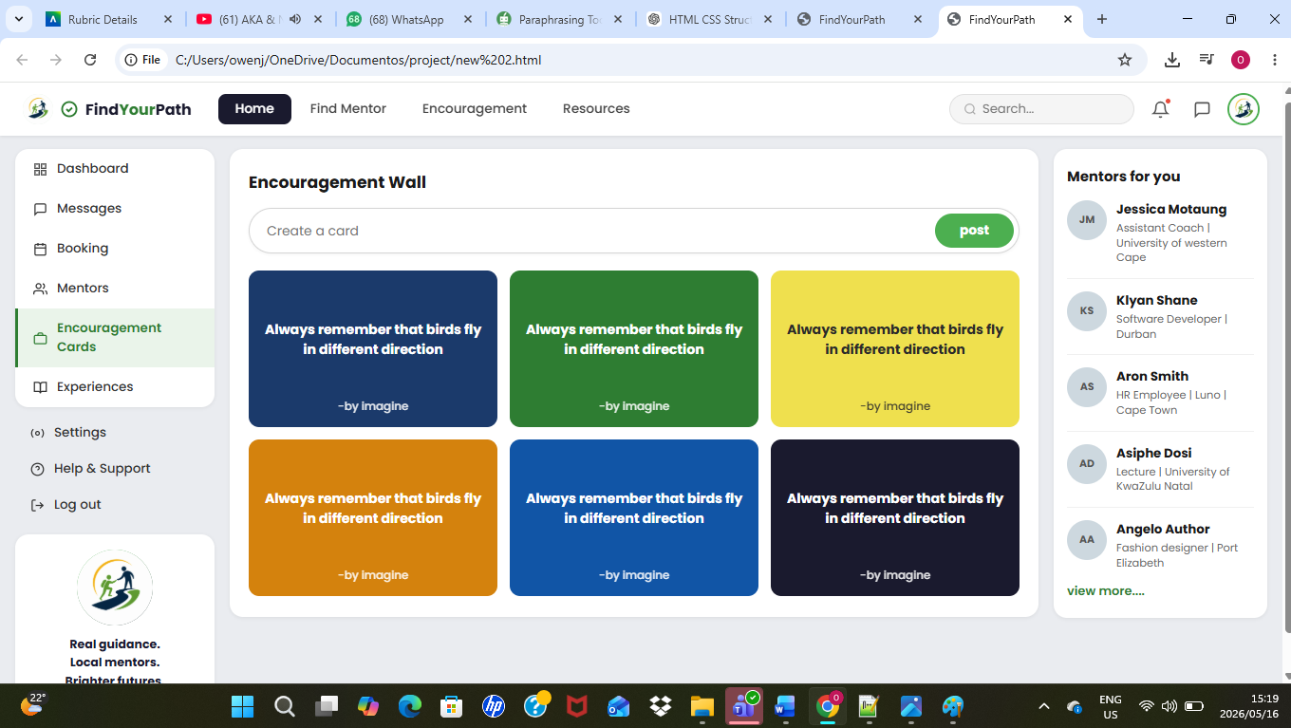

I also developed the Encouragement Wall page using HTML, CSS, and JavaScript. This feature allows users to view and share motivational messages in an interactive and visually appealing format. I ensured that the layout is clean and consistent with the overall design of the application, while JavaScript was used to add dynamic functionality such as displaying and updating messages. The page enhances user engagement by creating a positive space where encouragement and support can be shared.

Data requirements of subsystem
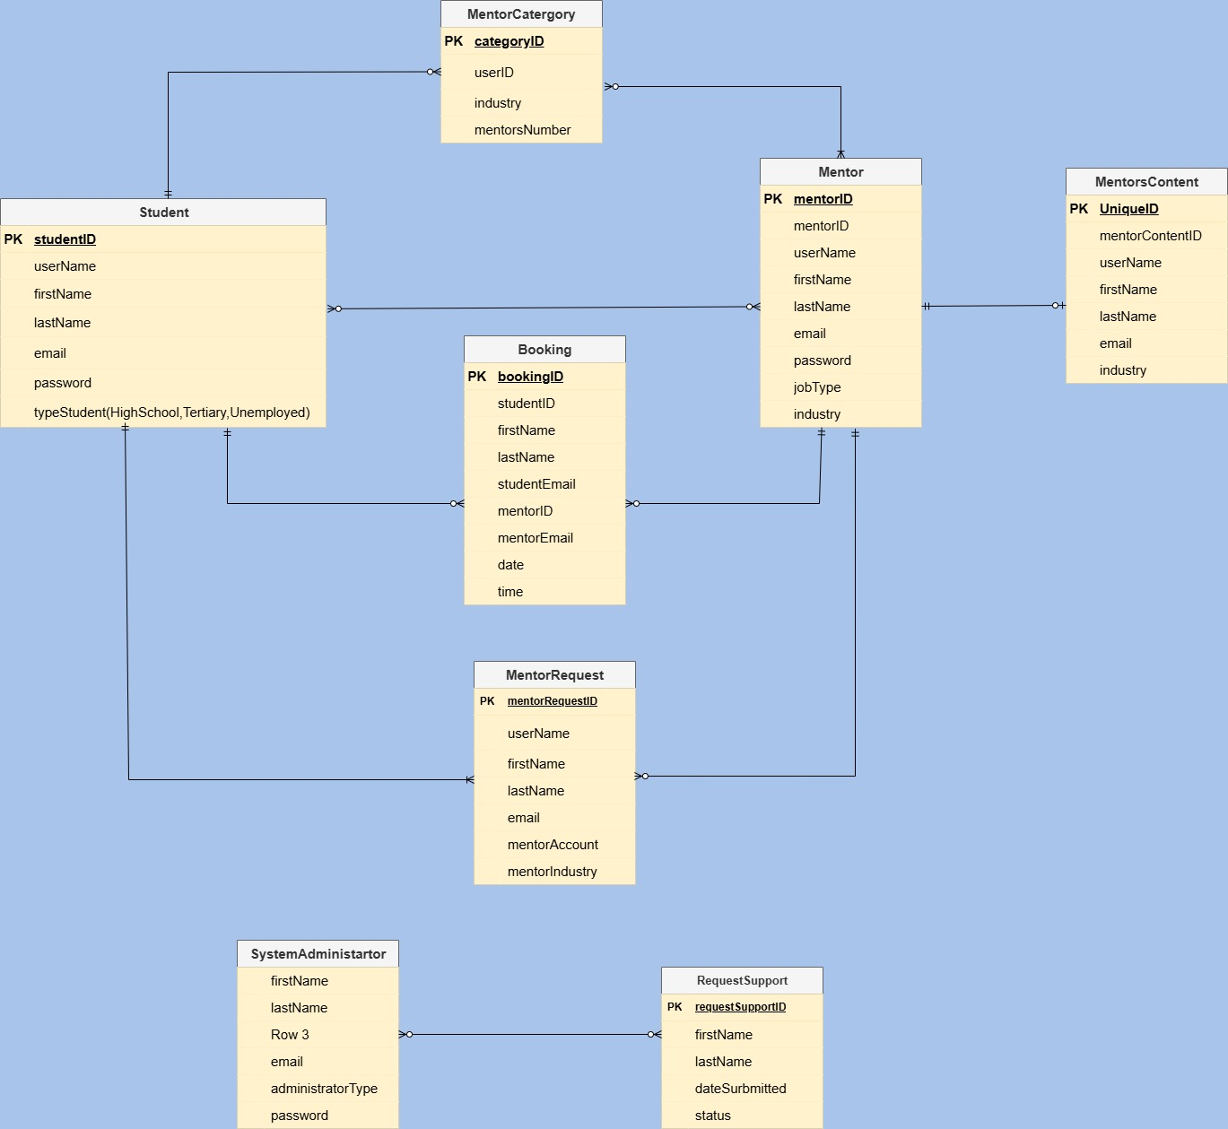

The 8 entities and their roles:
- Student — the learner. Has a typeStudent field with three roles: HighSchool, Tertiary, or Unemployed. Connects to Booking and MentorRequest.
- Mentor — the guide. Stores credentials like jobType and industry. Linked to MentorCategory (what domain they belong to), MentorsContent (their published materials), Booking (sessions they run), and MentorRequest (applications to become one).
- MentorCategory — a lookup/grouping table. Ties mentors to industries with a mentorsNumber count. One category can have many mentors; one mentor belongs to one category.
- Booking — the core transactional table. Joins a Student to a Mentor with a date and time. Stores both emails directly (denormalized), which suggests email notifications are a key feature.
- MentorRequest — an application table. Someone applies to become a mentor by submitting personal info and their desired industry. Links back to the Mentor table (presumably after approval), and to the Student who submitted the request.
- MentorsContent — content/resources published by mentors (articles, videos, etc.). Each piece is owned by one mentor. Has a UniqueID primary key and stores mentor identifying info plus industry.
- SystemAdministrator — the admin user. Has an administratorType field. Connected to RequestSupport, suggesting admins handle support tickets.
- RequestSupport — a support ticket table. Has status and dateSurbmitted (note the typo in the diagram). Managed by an admin.

Key relationships:
- MentorCategory → Mentor (one-to-many) One category (e.g. "Finance" or "Tech") can contain many mentors. Each mentor belongs to exactly one category. The mentorsNumber field in MentorCategory tracks how many mentors are in that category.
- Mentor → MentorsContent (one-to-many) One mentor can publish many pieces of content (articles, resources, guides). Each content item belongs to one mentor.
- Student → Booking ← Mentor (many-to-many via Booking) This is the core transactional relationship. A student can have many bookings; a mentor can appear in many bookings. The Booking table sits in the middle, resolving this into two one-to-many links — it holds the studentID, mentorID, date, and time of each session.
- Student → MentorRequest ← Mentor (many-to-many via MentorRequest) A student submits a request to become a mentor. Once approved, that request links back to the Mentor table. This is essentially a pathway — student applies, admin reviews, application becomes a mentor account.
- SystemAdministrator → RequestSupport (one-to-many) One admin can manage many support tickets. Each ticket has a status and submission date, allowing admins to track and resolve issues raised by users.

Mentorship System – Use case diagram
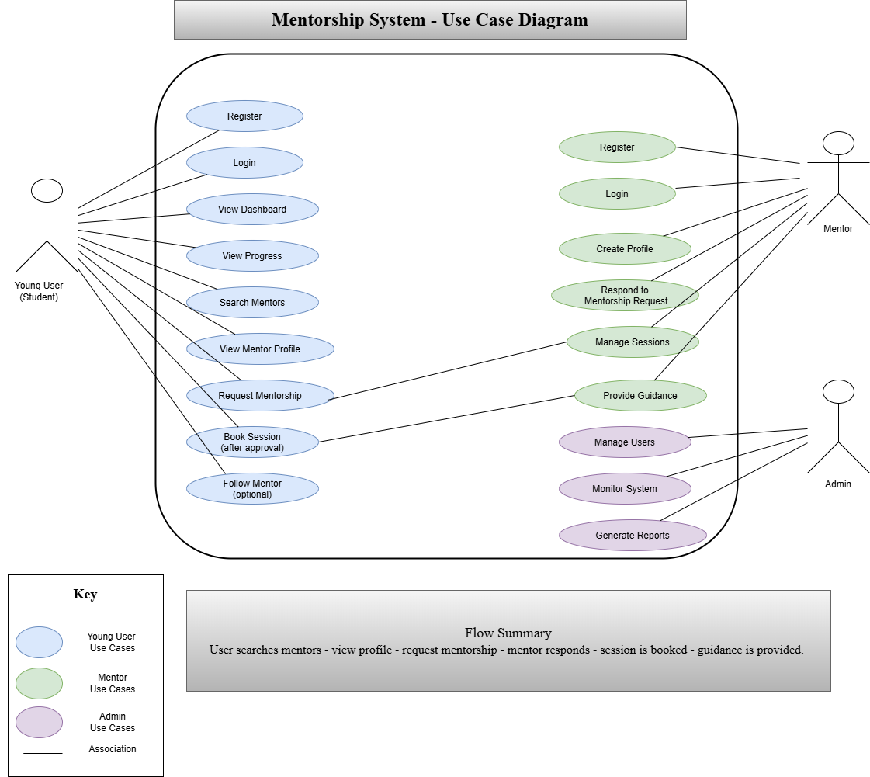

User Stories

1. Young Users (Students / Job Seekers)
- As a young user, I want to register an account so that I can access the platform.
- As a young user, I want to log in securely so that my personal information is protected.
- As a young user, I want to create and manage my profile so that mentors can understand my interests and career goals.
- As a young user, I want to search for mentors by career field so that I can find guidance relevant to my interests.
- As a young user, I want to request mentorship so that I can receive career advice.
- As a young user, I want to send messages to mentors so that I can ask questions and communicate easily.
- As a young user, I want to access career advice and resources so that I can learn about different career paths.
- As a young user, I want to update my profile and interests so that the system stays relevant to my goals.
- As a young user, I want to receive notifications when my request is accepted so that I stay informed.

2. Mentors (Experienced Professionals)
- As a mentor, I want to register an account so that I can join the platform.
- As a mentor, I want to log in securely so that my account is protected.
- As a mentor, I want to create a professional profile so that users can see my experience and background.
- As a mentor, I want to receive mentorship requests so that I can help young users.
- As a mentor, I want to accept or decline requests so that I can manage my availability.
- As a mentor, I want to communicate with mentees through messaging so that I can provide guidance.
- As a mentor, I want to update my profile so that my information stays accurate.

3. System Administrator
- As an administrator, I want to manage user accounts so that the system runs smoothly.
- As an administrator, I want to monitor system activity so that I can ensure everything is functioning correctly.
- As an administrator, I want to access system reports so that I can track usage and performance.

4. General System (Applies to All Users)
- As a user, I want the system to store my information securely so that my data is safe.
- As a user, I want a user-friendly interface so that the platform is easy to use.
- As a user, I want basic messaging functionality so that I can communicate without needing complex tools.

5. Team
- As a team member, I want to use WhatsApp for quick updates so that communication is fast and efficient.
- As a team member, I want weekly meetings so that we can discuss progress and challenges.
- As a team member, I want shared documents so that we can collaborate on work in real time.
- As a team member, I want clear task allocation so that I know my responsibilities.

Coding process
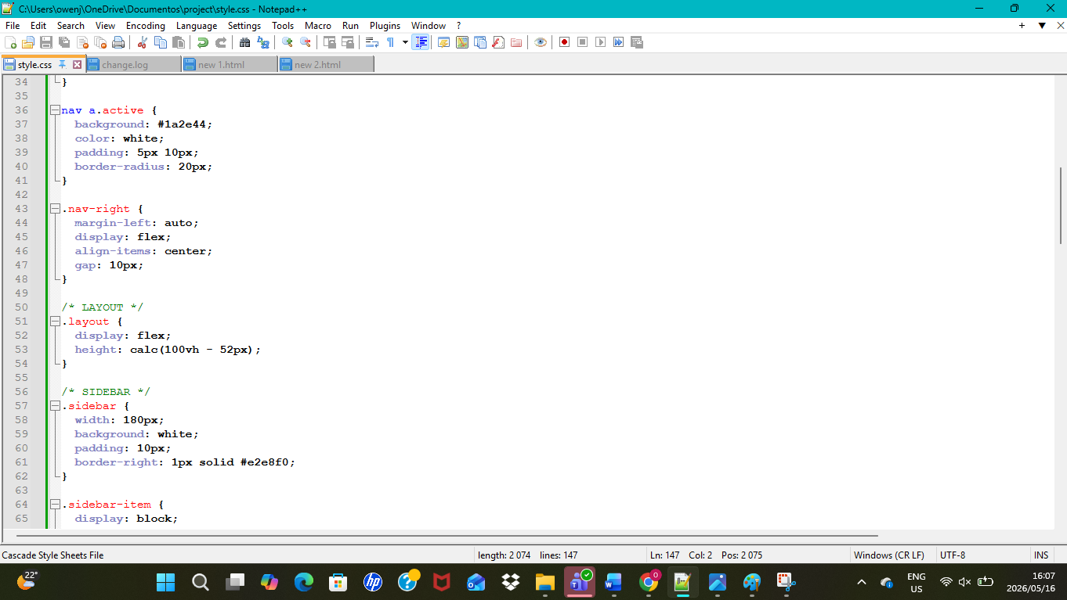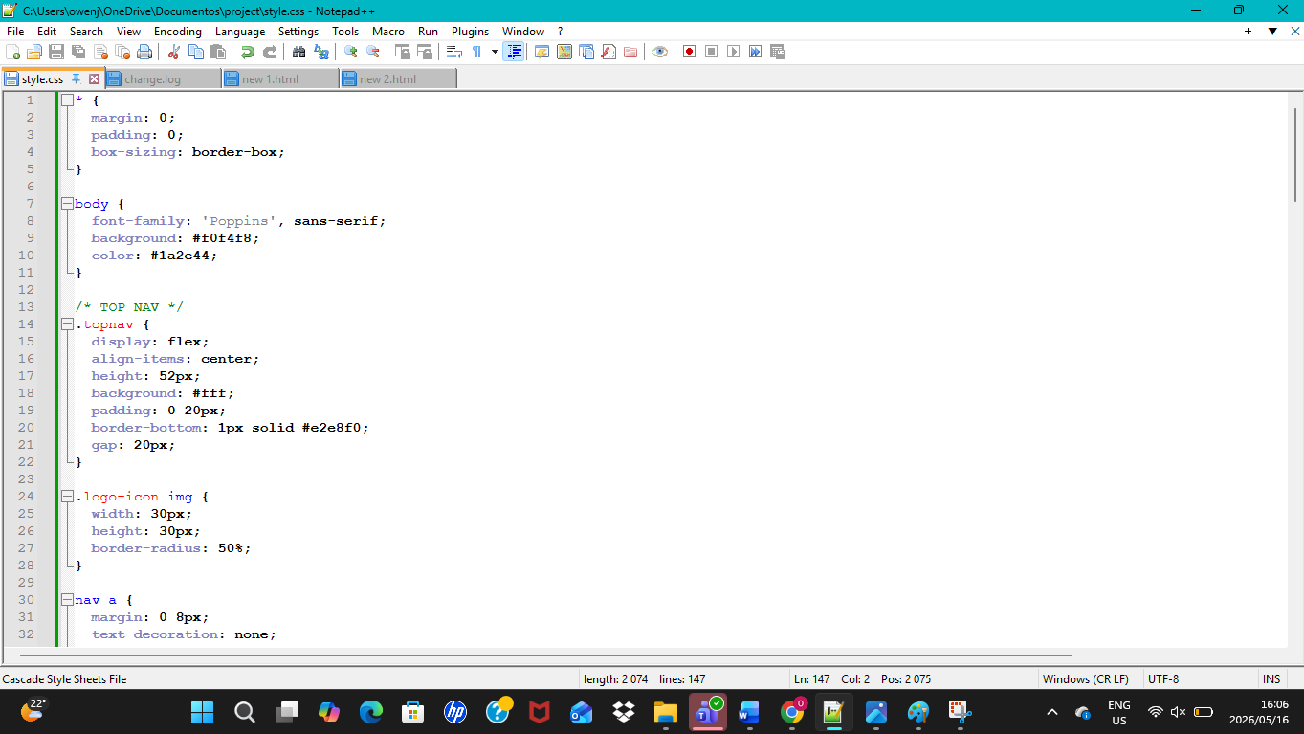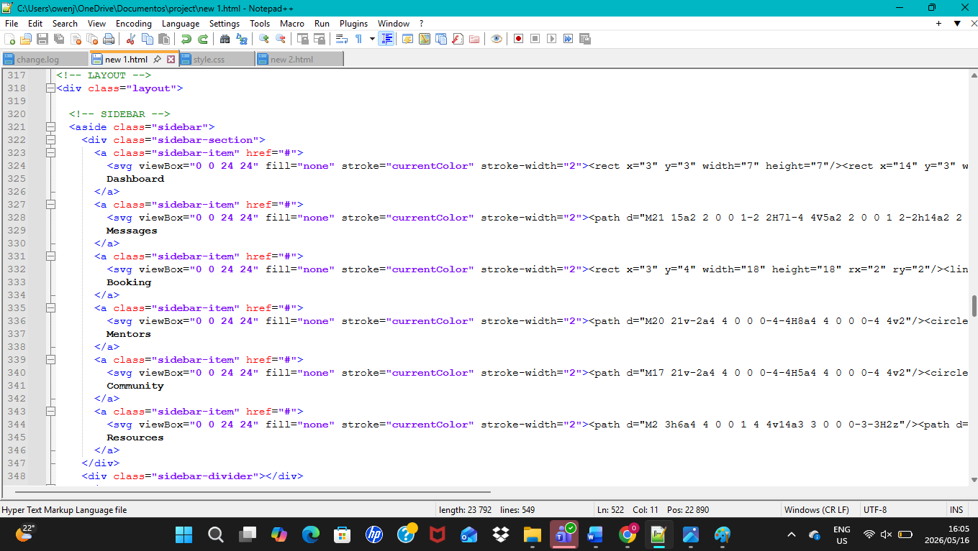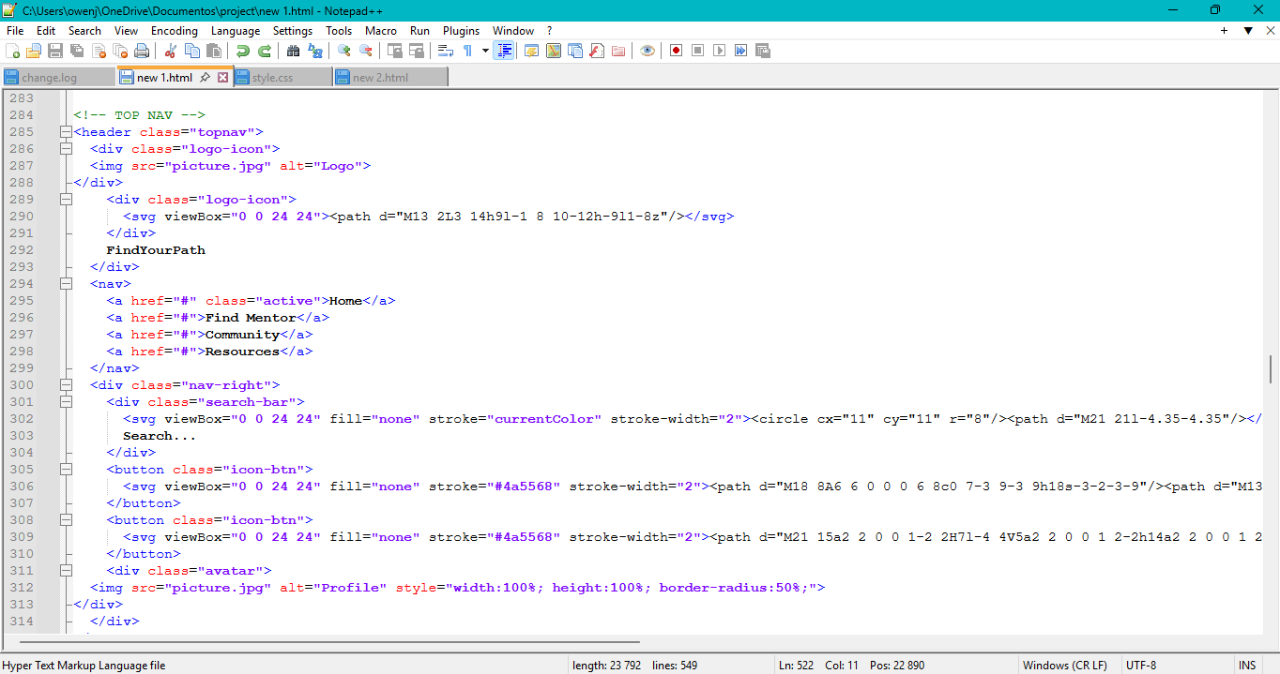

The development of the front-end interface is the exclusive emphasis of this project. In order to produce an interactive and visually structured user experience that is consistent with the initial wireframe design, the system was created and built using HTML, CSS, and JavaScript.
No backend functionality has been incorporated as of yet. Making sure the client-side interactions, layout, and design are all fully functional and responsive was the main focus. The material was organised using HTML, the visual design and layout were handled by CSS, and the pages' dynamic behaviour and interactivity were added using JavaScript.
The wireframe was successfully translated into a workable front-end prototype using this method, which can then be linked to a backend system for complete functionality.

Reflection
With six people in our company, we split up the labour equally so that every component of the project could be finished quickly. While Olona and Zahrah worked on the use case diagrams, Mvuyisi and I created the ERD (Entity Relationship Diagram). The wireframes were designed by Onika and Siphesihle.
We set aside time to check each other's work after finishing our separate assignments to make sure it was consistent and of high quality. After that, we had a group meeting where everyone gave an update on their work and discussed how they contributed to the project. This enabled us to verify that every work was properly finished and compliant with the project specifications.

We further separated the wireframes into distinct sections after the first design phase was over, giving each member a page to work on. After that, we started utilising HTML, CSS, and JavaScript to code the pages we were given.
At our final meeting, each participant gave a presentation on their coding progress. This made it possible for us to monitor progress, exchange criticism, and make sure that every element was in line with the project's overall design. All things considered, the team worked well together, and each person made a significant contribution to the project's success.

Challenges Encountered
My partner and I encountered challenges when developing the ERD (Entity Relationship Diagram) during the project. At first, we had trouble correctly identifying the relationships and structure. But by consulting our Information Systems notes and watching YouTube training videos, we were able to get past this obstacle. We were able to develop an accurate ERD as a result of this improved comprehension.

Working with JavaScript presented another difficulty for me because, before to this assignment, I had little experience with it. Implementing the necessary functionality was first challenging for me. However, I was able to properly code the necessary elements after steadily improving my comprehension through viewing tutorial videos and practicing step-by-step.
These challenges increased my grasp of front-end development and system design while also enhancing my problem-solving abilities.

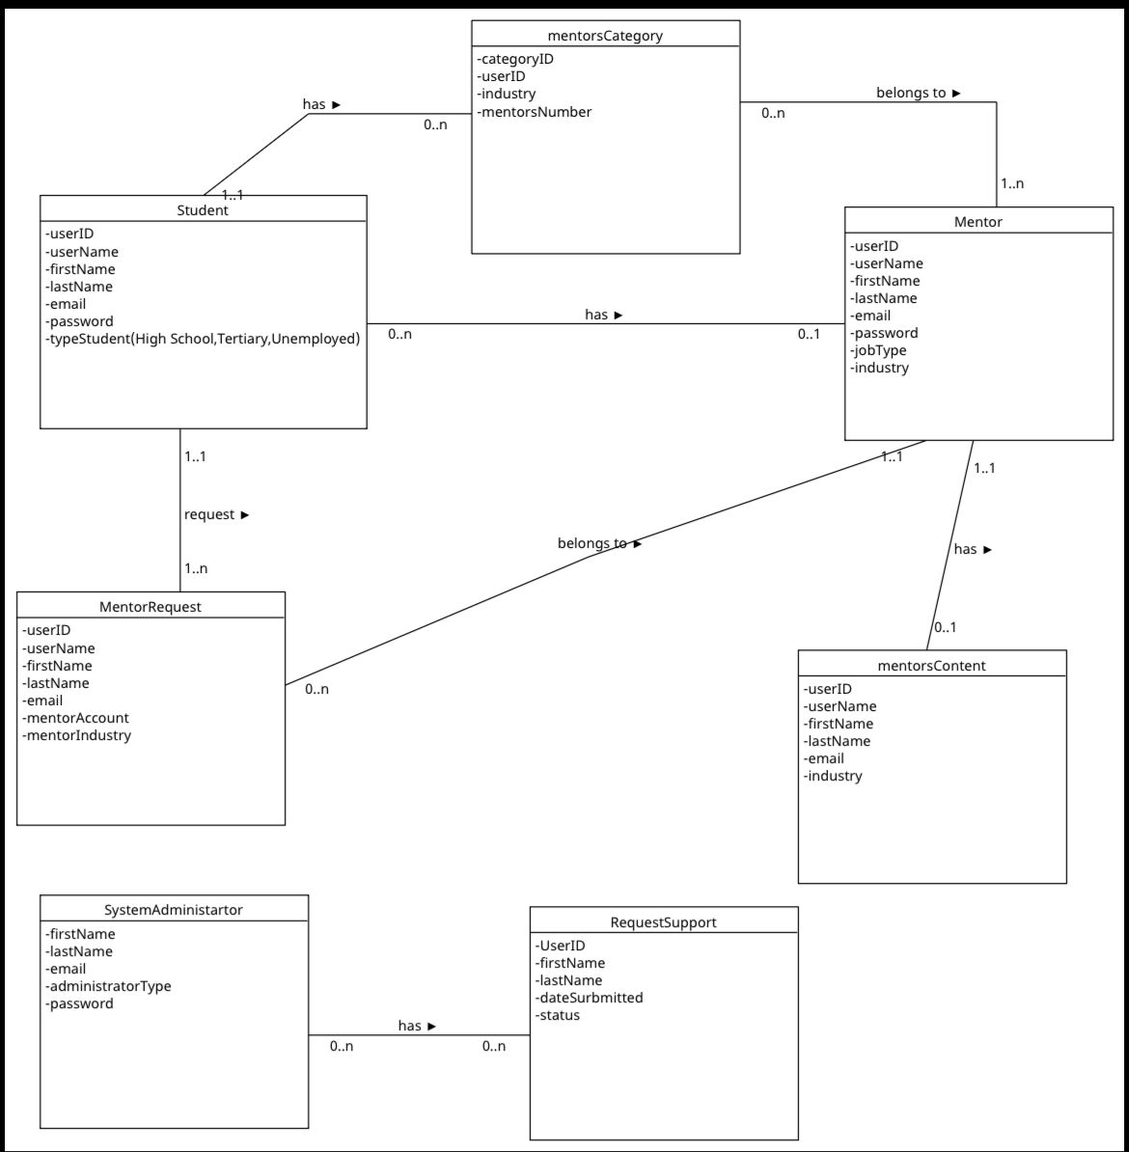
The team was not happy with our first ERD because it did not entirely satisfy the requirements. As a result, we updated it by learning more about ERD concepts and conducting in-depth study. As a result, we were able to enhance the design and create an ERD that more accurately and systematically depicts the system.

